Project Design Phase-I

Solution Architecture

|  |  |
| --- | --- |
| Date | 16 October 2022 |
| Team ID | PNT2022TMID36121 |
| Project Name | Project - IoT Based Safety Gadget for Child Safety Monitoring and Notification |
| Maximum Marks | 4 Marks |

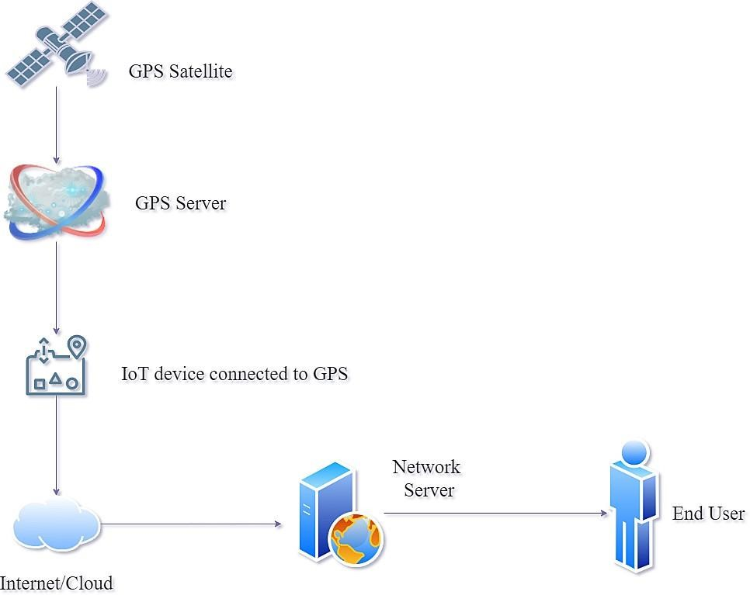Solution Architecture:

➤ Using the Minimum Viable Architecture model can ultimately result in a highly polished end product as it relies on testing assumptions with small experiments and guiding development using the findings of said experiments.

➤ Providing a flexible framework that can help achieve target business objectives, MVA responds to evolving customer requirements and technologies and can go a long way in promoting agility.

* The safety of a child at a large public event is a major concern for event organizers and parents. We address this important concern and proposes an architecture model of the

IoT-enable smart child safety tracking digital system.

* This IoT-enabled digital system architecture integrates the Cloud, Mobile and GPS technology to precisely locate the geographical location of a child on an event map.
* The proposed architecture model describes the people, information, process, and technology architecture elements, and their relationships for the complex IoT-enable smart child safety tracking digital system.

Outline Architecture:

